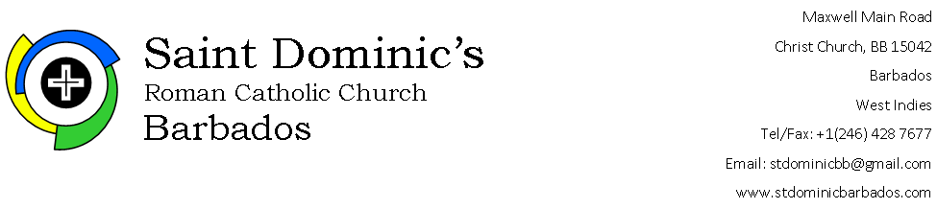

APPLICATION FOR REGISTRATION FOR CONFIRMATION

Kindly see Instructions and Details below

Name of candidate ……………………………………………………………………….

Candidate’s email ……………………………………………… Candidate’s cell no …………………………..

Date of birth (date/month/year) …………………………………………………..

Home Address …………………………………………………………………………......

……………………………………………………………………………… Home phone no ……………………………

Mother’s name ……………………………………………………………………………..

Mother’s email ……………………………………………………………… Mother’s cell no ……………………….……...

Father’s name ……………………………………………………………………………….

Father’s email ………………………………………………………..………….. Father’s cell no ……………………….…….

Guardian’s name ……………………………………………………………………

Guardian’s email …………………………………………………………….. Guardian’s cell no ……………………………

In addition, kindly:

- indicate by * the primary contact for and/or behalf the candidate;

- attach a copy of your child’s baptism certificate;

- advise which Catholic church the candidate attends…………..………………………………………………….

- advise where your child received First Holy Communion……………………………………………………….

- advise if your child has any learning difficulties (Dyslexia, Auditory or Sensory Processing Disorder, ADHD)..................................................................................................................................
…………………………………………………………………………………………………………………………………………………………..

Instructions and Details

- Submission of Application Form: stdominicsconfirmation@gmail.com

- Submission of an application form is not an automatic admission into the Confirmation programme.

- Children of parishioners of St. Dominic’s and candidates who received their First Communion at St. Dominic’s will be given first preference.

- Registration Fee:
  - BDS$80.00
  - Payable on: 29th September, 2023 (first day of Confirmation class)

- The Confirmation programme is for two (2) years.

- Classes will be held on Friday evening from 7:00 p.m. – 9:00 p.m. Details to follow

- During the programme:
  - candidates are expected to attend Mass on weekends; and
  - special Masses for the candidates will be held which they will be required to attend.

- A parents’/guardians’ meeting will be held with the Catechists and the Priests on Friday 29th September, 2023 at 7:00 p.m. Details will be provided closer to the time.

[the remainder of the page is left intentionally blank]

This information will be kept confidential and is only garnered to assist the Catechists in terms of delivery/teaching of material

